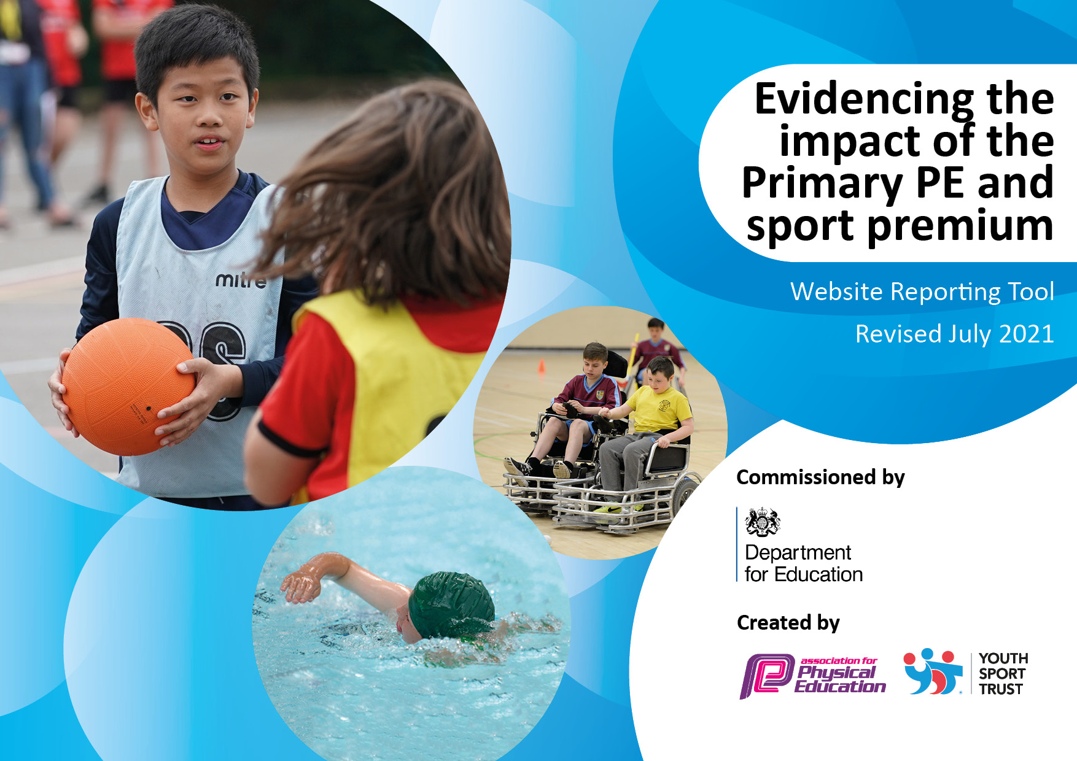
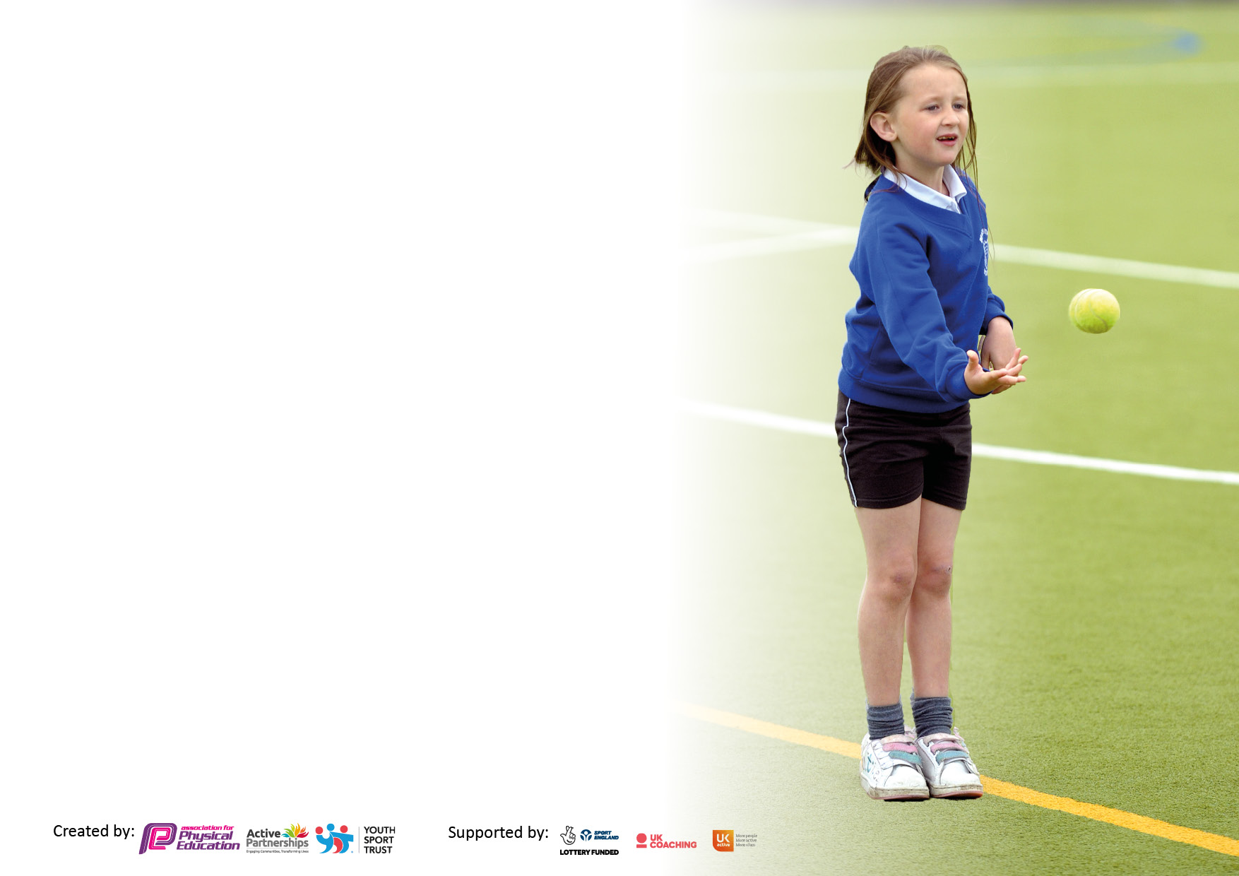

It is important that your grant is used effectively and based on school need. The Education Inspection Framework makes clear there will be a focus on ‘whether leaders and those responsible for governors all understand their respective roles and perform these in a way that enhances the effectiveness of the school’.

Under the Quality of Education Ofsted inspectors consider:
Intent - Curriculum design, coverage and appropriateness
Implementation - Curriculum delivery, Teaching (pedagogy) and Assessment
Impact - Attainment and progress

To assist schools with common transferable language this template has been developed to utilise the same three headings which should make your plans easily transferable between working documents.

Schools must use the funding to make additional and sustainable improvements to the quality of Physical Education, School Sport and Physical Activity (PESSPA) they offer. This means that you should use the Primary PE and sport premium to:

- Develop or add to the PESSPA activities that your school already offer
- Build capacity and capability within the school to ensure that improvements made now will benefit pupils joining the school in future years
- The Primary PE and sport premium should not be used to fund capital spend projects; the school’s budget should fund these.

Pleasevisitgov.ukfortherevisedDfEguidanceincludingthe5keyindicatorsacrosswhichschoolsshoulddemonstrate animprovement.Thisdocumentwillhelpyoutoreviewyourprovisionandtoreportyourspend.DfEencouragesschools to use this template as an effective way of meeting the reporting requirements of the Primary PE and sport premium.

We recommend you start by reflecting on the impact of current provision and reviewing the previous spend.

Schools are required to publish details of how they spend this funding, including any under-spend from 2019/2020, as well as on the impact it has on pupils’ PE and sport participation and attainment. All funding must be spent by 31st July 2022.

We recommend regularly updating the table and publishing it on your website throughout the year. This evidences your ongoing self-evaluation of how you are using the funding to secure maximum, sustainable impact. Final copy must be posted on your website by the end of the academic year and no later than the 31st July 2021. To see an example of how to complete the table please click HERE.
Created by: Supported by:

Details with regard to funding
Please complete the table below.

How much (if any) do you intend to carry over from this total fund into 2021/22? | £8000.00
Total amount allocated for 2021/22 | £17107.00
Total amount of funding for 2021/22. To be spent and reported on by 31st July 2022. | £1018.05
Swimming Data
Please report on your Swimming Data below.

Meeting national curriculum requirements for swimming and water safety.

N.B. Complete this section to your best ability. For example, you might have practised safe self-rescue techniques on dry land which you can then transfer to the pool when school swimming restarts.
Due to exceptional circumstances priority should be given to ensuring that pupils can perform safe self rescue even if they do not fully meet the first two requirements of the NC programme of study
What percentage of your current Year 6 cohort swim competently, confidently and proficiently over a distance of at least 25 metres?  N.B. Even though your pupils may swim in another year please report on their attainment on leaving primary school at the end of the summer term 2021.  Please see note above | 78%
What percentage of your current Year 6 cohort use a range of strokes effectively [for example, front crawl, backstroke and breaststroke]?  Please see note above | 69%
What percentage of your current Year 6 cohort perform safe self-rescue in different water-based situations? | 64%
Schools can choose to use the Primary PE and sport premium to provide additional provision for swimming, but this must be for activity over and above the national curriculum requirements. Have you used it in this way? | Yes

Action Plan and Budget Tracking
Capture your intended annual spend against the 5 key indicators. Clarify the success criteria and evidence of impact that you intend to measure to evaluate for pupils today and for the future.

Academic Year: 2020/21 | Total fund allocated: £20070 | Date Updated: 21st July 2022
Key indicator 1: The engagement of all pupils in regular physical activity – Chief Medical Officers guidelines recommend that primary school pupils undertake at least 30 minutes of physical activity a day in school |  |  |  | Percentage of total allocation:
 |  |  |  | 47.5%
Intent | Implementation |  | Impact
Your school focus should be clear what you want the pupils to know and be able to do and about  what they need to learn and to  consolidate through practice: | Make sure your actions to achieve are linked to your intentions: | Funding allocated: | Evidence of impact: what do pupils now know and what can they now do? What has changed?: | Sustainability and suggested next steps:
Encourage children to participate in sport and be active outside of school through afterschool and lunchtime clubs- increased participation in physical activity and increased pupil fitness levels.  2 x 1 hour PE Sessions (from GetSet) each week for all children in school.  Active blast to engage children in regular, cross-curricular physical activity breaks throughout the day  (active breaks and mental health and wellbeing)  To support children’s physical and mental well-being, improved levels of concentration as well as physical fitness- changes to the daily routine increased equipment to support more engaging activities at break and lunchtime.  Current year 5 pupils to learn and be able to ride a peddle bike by the time the leave Castle Academy in Year 6 2022.  All pupils to know how to keep safe on a scooter, balance bike or peddle bike outside  of school. | Implementation lunchtime clubs. e.g. Archery, Netball, Athletics club, cricket and multi-skills.  Further CPD from GetSet and NSSP to broaden subject knowledge of PE and sport teaching. Purchase of essential equipment and resources to enable a wide variety of sports to be taught effectively  All classes to use active blast to engage children in active breaks in or between lessons to increase regular physical activity (twice weekly)  Run to Tokyo- Painted outline on the field which helps them keep track of the number of laps they have ran.  Introduce cycling onto the PE curriculum. Take part in bike ability and train staff to lead session in cycling, balance biking and scootering. | £5,941.95  (Cost of coaches)  £ 1,710  (equipment)  £660  £Included in Get set 4 PE  £1083.00  £132.00 | Gives children opportunity to move more during class time to aid focus during lessons.  New sports equipment purchased, with impact of increased participation in lessons and improvement of skills, as more children have equipment that is fit for purpose.  Children take part in timetabled run. Children have a painted route to follow on the playground – which helps them keep track of the number of laps they have run.  Increases the numbers of pupils cycling to school. | Continue to monitor the quality of additional clubs and he wear and tear of equipment.  Replenish equipment and resources to ensure continued interest and participation.  Survey pupils on if they can ride, access to bikes /competency and confidence levels.  Investment to be made in bikes to increase numbers.
Key indicator 2: The profile of PESSPA being raised across the school as a tool for whole school improvement |  |  |  | Percentage of total allocation:
 |  |  |  | 20.5%
Intent | Implementation |  | Impact
Your school focus should be clear what you want the pupils to know and be able to do and about  what they need to learn and to  consolidate through practice: | Make sure your actions to achieve are linked to your intentions: | Funding allocated: | Evidence of impact: what do pupils now know and what can they now do? What has changed?: | Sustainability and suggested next steps:
To encourage pupils to take on leadership roles that support sport and physical activity within the school (Sports Leaders).  To embed physical activity into the school day through active travel to and from school, active break times and active lessons and teaching.  Pupils, staff and parents are aware of sporting activities and achievements across the school. Through Olympic day celebration.  Focus on Olympic vision/ values.  Introduce – beginners swimming from year 4 | Sports Leader Pupil Advocates- external and internal training for our new leaders and mid-day supervisor training. NSSP/PE Lead to train. Pupils to be provided with badges.  All classes to use active blast to engage children in active breaks in or between lessons to increase regular physical activity.  Whole Trust event.  Walk to Tokyo 100% participation.  Whole school participation in a range of Olympic events.  Host SEND Olympic event.  Upcoming internal house sporting events to be advertised on the dedicated sports display board. Results and photos to be displayed. Greater visibility and celebration of sporting achievements: weekly assemblies (virtual), weekly newsletter, etc.  Continue to introduce swimming to year 4 pupils. | £2,200  £ Included in get set for PE.  £1000  £930 | Children take part in regular active blast breaks throughout the day. Gives children opportunity to move more during class time to aid focus during lessons.  100% attendance in whole school and Trust events.  Mental and physical health promoted. | PE leads to monitor and measure impact use of active blast through pupil and staff voice questionnaires.  Success of the Olympic event has led it to be a planned in as an annual event, linking with school sports day.  Planning committee hopes that its legacy will increase uptake in clubs and mass participation across sports.  This has increased the number of pupils meeting the swimming requirements.

Key indicator 3: Increased confidence, knowledge and skills of all staff in teaching PE and sport |  |  |  | Percentage of total allocation:
 |  |  |  | 22%
Intent | Implementation |  | Impact
Your school focus should be clear | Make sure your actions to | Funding | Evidence of impact: what do | Sustainability and suggested
what you want the pupils to know | achieve are linked to your | allocated: | pupils now know and what | next steps:
and be able to do and about | intentions: |  | can they now do? What has
what they need to learn and to |  |  | changed?:
consolidate through practice:
To provide staff with professional development, mentoring, training and resources to help them teach PE and sport more effectively to all pupils and embed physical activity across your school.  The swimming TA is confident in their role to support the swimming coach and to promote excellence in swimming.  Provide staff with professional development, mentoring, training and resources to help ensure confidence in teaching and delivering high quality PE resulting in higher quality teaching. | To use qualified sports coach to work alongside teachers to team teach- enhance or extend current opportunities.  PE leaders to attend training for GETSET4PE curriculum design and 3Is Training CPD from Teach Active to support teacher delivering sessions across the school.  TA to attend training/team teaching/modelling and observing swimming coach.  Staff are trained appropriately to ensure quality of teaching. | £2,970  NSSP  Twilight session for staff Included in GETSET fee  £TBC  (Not happened yet)  £1500 | Children taking part in lessons that are confidently delivered by staff.  Teachers confidently delivering lessons with increased confidence and skills.  PE leads to be secure in whole school curriculum overview and 3Is.  Teachers confidently delivering teach active break sessions alongside curriculum subjects.  All classes taking part in active blast advent. Making sure we do one active blast every day.
Key indicator 4: Broader experience of a range of sports and activities offered to all pupils |  |  |  | Percentage of total allocation:
Intent | Implementation |  | Impact | 2%
Your school focus should be clear | Make sure your actions to | Funding | Evidence of impact: what do | Sustainability and suggested
what you want the pupils to know | achieve are linked to your | allocated: | pupils now know and what | next steps:
and be able to do and about | intentions: |  | can they now do? What has
what they need to learn and to |  |  | changed?:
consolidate through practice:
Additional achievements:  Support and involve the least active children by providing targeted activities and running or extending school sports opportunities and offering a wider range of after school clubs.  Internal House competitions held termly | Reception to Y6 to take part in intra-school competitions and have the opportunity to enrol in a wider range of sports clubs.  Internal event between school houses.  Whole school sports day. | £500  (equipment/ specialist coaching cost) | Club registers are now consistent, with greater uptake by specific targeted children.  Confidence, wellbeing, and physical activity improved massively as was behaviour. | At the beginning of the year, highlight at least 1 sporting event per half term to attend – preferably to include different year groups, SEND focus.  Take a teacher survey to see what skill set is within the school, to see if a range of clubs could be run, with a focus of participation from a range of children.  Monitor attendance of sports clubs termly and ensure clubs are well published to parents.  Advertise and increase options for children to attend holiday camps.

Key indicator 5: Increased participation in competitive sport |  |  |  | Percentage of total allocation:
 |  |  |  | 2%
Intent | Implementation |  | Impact
Your school focus should be clear | Make sure your actions to | Funding | Evidence of impact: what do | Sustainability and suggested
what you want the pupils to know | achieve are linked to your | allocated: | pupils now know and what | next steps:
and be able to do and about | intentions: |  | can they now do? What has
what they need to learn and to |  |  | changed?
consolidate through practice:
7 a-side and 5 a-side football  Athletics  Hockey  Netball  Cricket  New age kurling  Enter sport competitions  offered by NSSP.  Host SEND paralympic event. |  | £225  £cost included in NSSP  £200 | Participation in competitions –  Externally.  Participation in NSSP county-wide competitions.  Increased SEND participation across school in competitive sport. | Netball team to have  weekly training and host home games.  Ensure that funding is put aside at the  beginning of the year to allow for transportation  for events.  Ensure every year have opportunity to participate in  comps through NSSP, i.e.:  host events with other  schools.  Promote and track a termly  house competition  where the children are encouraged to ‘beat their best’.

Signed off by
Head Teacher:
Date:
Subject Leader: | Claire Husbands
Date:
Governor:
Date:

